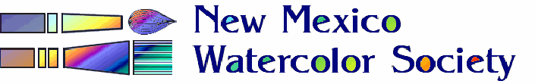

”Alternate Spaces”

Announces a CALL for ENTRIES for the fall exhibition at

Salud! de Mesilla

1800 Avenida de Mesilla

August 1st – September 3rd, 2018
Business hours: Sunday –Monday 11 am – 9 pm - - Closed on Tuesday

Entries are needed for the fall exhibition. They need to be submitted as digital images, jpeg format, no larger than 1200 pixels in the longest dimension, with no frame. They are to be emailed to me no later than Monday July 23rd. There are a limited number of spaces available (approx.20-30)..

Submit early to avoid disappointment later.

The details needed to accompany each entry (limit two per person) has to include the Name of the artist as it is to appear on the label, The Title of the art work, The Price of the piece, Your Phone Number or Email address (whichever you prefer) for the buyer to contact you. Please include the Size of the piece (outside frame dimension, landscape or portrait) so that consideration can be made to appropriately display the art work. Remember, if you desire, submit with your entry(ies) and Artist Biography. Though entries are limited to two per artist, please indicate which one you would prefer to use as an entry if we need to limit entry to one per entrant due to a larger than usual number of entrants. Please get entries in by the deadline date (Monday July 23rd) to allow for printing the art labels and getting a show banner printed with images for the sandwich board. Earlier submission will make inclusion in the printed materials.
The Salud! will take no commission fees and all sales will be payable to you directly.
Entry of the art pieces will automatically give the NMWS-SC Alternate Spaces the right to use the image for advertising purposes, and only for that purpose.

The drop off day chosen by the host establishment is Monday, Ju;y 30th after lunch and leave the piece(s) there. Your piece(s) should arrive “ready to hang” with the Name of the artist and Title of the art work on the back for identification. The host establishment has indicated that they will hang the art work.

Paul Vakselis vakselis@gmail.com 575-496-6400

Paul Vakselis, Alternate Spaces, Chair

