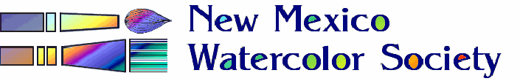

”Alternate Spaces”

ENTRY FORM

Café de Mesilla, Las Cruces, NM February 1st^{st} - March 31st, 2020

Entry Deadline: Monday, January 27th, 2020

Please complete the entire form carefully, typing into the text boxes all information as you wish to have it appear in the show. The asterisked items must be completed. When completed, save the document and email it back to me. Include as attachments your paintings’ jpeg images. (see prospectus for instructions) Attach a BIO if desired to be included in the show Artist Biography folder.

Date: mo day ENTRY # 1 ENTRY # 2 (space permitting)
Artist Name: *

Title: *

Price: *
Media: *
Image Size: (HxW “) (< 11 x 15) (< 11 x 15)
Framed Size: (H xW “)
Notes:
Contact Info: * (phone, email or both)
Paul Vakselis vakselis@gmail.com 575-496-6400
Paul Vakselis, Alternate Spaces, Chair

